SNYDERVILLE BASIN WATER RECLAMATION DISTRICT RECEIVES
NATIONAL ENVIRONMENTAL ACHEIVEMENT AWARDS

PARK CITY, UTAH (August 2026) – The Snyderville Basin Water Reclamation District (SBWRD) recently received two National Environmental Achievement Awards.
National Environmental Achievement Awards:
Snyderville Basin Water Reclamation District was honored by the National Association of Clean Water Agencies (NACWA) for outstanding compliance and performance in meeting federal water quality requirements. The utility was recognized at a July 15 ceremony during NACWA’s 2026 Utility Leadership Conference in Cleveland.
The two Platinum Peak Performance Awards were presented to recognize SBWRD’s strict adherence to regulations and a consistent, conscientious approach to protect human health and the local environment, year after year.
Award #1: The East Canyon Water Reclamation Facility has achieved 100%
compliance with all environmental permit requirements for 22 consecutive years.

Award #2: The Silver Creek Water Reclamation Facility has achieved 100%
compliance with all environmental permit requirements for 23
consecutive years.

NACWA CEO Adam Krantz commended the recipients, noting:
“The utilities receiving NACWA’s Peak Performance Awards have demonstrated an extraordinary commitment to operational excellence and environmental protection,” he said. “These achievements reflect the hard work and dedication of the utility professionals who ensure clean water services remain reliable, effective, and resilient for the communities they serve. NACWA is proud to celebrate their accomplishments and the critical role they play in safeguarding public health and the environment.”
Mike Luers, SBWRD:
“Our goal at the Snyderville Basin Water Reclamation District is to protect human health and our local environment,” said Michael Luers, General Manager at SBWRD. “We are honored to be recognized for our commitment to the Snyderville Basin/Park City community.”
For more information on Snyderville Basin Water Reclamation District’s water quality efforts, please contact Michael Luers, General Manager, or visit us at www.sbwrd-ut.gov.
#####

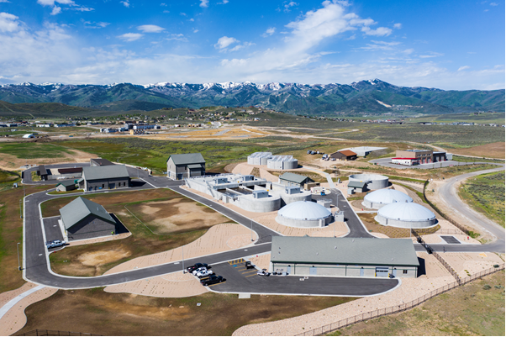
Silver Creek Water Reclamation Facility
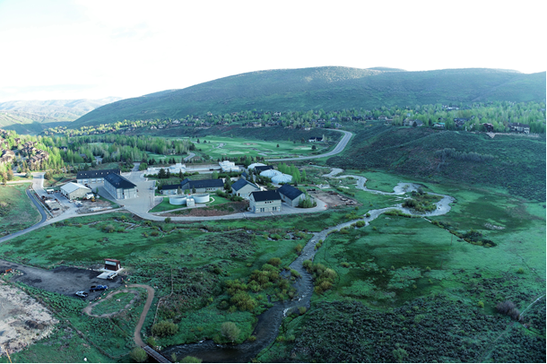
East Canyon Water Reclamation Facility

